RDM630 Specification

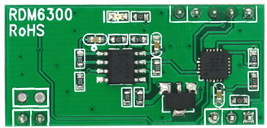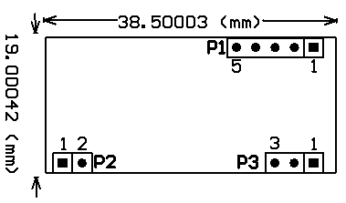
1．Pin Definition （WEIGAND）： 2. Pin definition （TTL interface RS232 data format）：
P1： P1：
PIN1 DATA0 PIN1 TX
PIN2 DATA1 PIN2 RX
PIN3 PIN3
PIN4 GND PIN4 GND
PIN5 +5V(DC) PIN5 +5V(DC)

P2: P2:
PIN1 ANT1 PIN1 ANT1
PIN2 ANT2 PIN2 ANT2

P3: P3:
PIN1 LED PIN1 LED
PIN2 +5V(DC) PIN2 +5V(DC)
PIN3 GND PIN3 GND
Specification and Parameter：
Frequency | 125KHz
Baud Rate | 9600（TTL Electricity Level RS232 format）
interface | Weigang26 Or TTL Electricity Level RS232 format
Power supply | DC 5V（±5%）
Current | < 50Ma
Operating range | ＞50mm（Depend on Card/Tag shape, manufacturer）
Expand I/O port | N/A
Indication light | N/A
Working temperature | -10℃ ~ +70℃
Storage temperature | -20℃ ~ +80℃
Max. humidity | Relative humidity 0 ~ 95%
Size | 38.5mm×19mm×9mm

Wiegand Format 26bit output data format
Read only ID as 4 byte, form as below:-
:
D37 | D36 | D35 | D34 | D33 | D32 | D31 | D30
D27 | D26 | D25 | D24 | D23 | D22 | D21 | D20
D17 | D16 | D15 | D14 | D13 | D12 | D11 | D10
D07 | D06 | D05 | D04 | D03 | D02 | D01 | D00

Wiegand Format 26 bits format form by 26 bits data which including 24 bit user data and 2 bit parity bit. As far as module concerned, former 12bit of 24 bit data is even & the behind 12bits is odd.
24 bit data correspond to 32 bit is read only 24bit which behind ID, I.E. D27-D20, D17-D10, D07-D00,
Output data format as chart below:

位 | 0 | 1 | 2 | 3 | 4 | 5 | 6 | 7 | 8 | 9 | 10 | 11 | 12 | 13 | 14 | 15 | 16 | 17 | 18 | 19 | 20 | 21 | 22 | 23 | 24 | 25
 | PE | D | D | D | D | D | D | D | D | D | D | D | D | D | D | D | D | D | D | D | D | D | D | D | D | PO
 |  | E | E | E | E | E | E | E | E | E | E | E | E | O | O | O | O | O | O | O | O | O | O | O | O
 |  | D 2 7 | D 2 6 | D 2 5 | D 2 4 | D 2 3 | D 2 2 | D 2 1 | D 2 0 | D 1 7 | D 1 6 | D 1 5 | D 1 4 | D 1 3 | D 1 2 | D 1 1 | D 1 0 | D 0 7 | D 0 6 | D 0 5 | D 0 4 | D 0 3 | D 0 2 | D 0 1 | D 0 0
Thereinto :
-  PE is even bit, PO is odd bit;
-  E is the data bit which was involved in even, O is the data bit which was involved in odd;
-  DXX is the data bit which correspond to Mifare@ Standard & Light card read only ID;
-  Wiegand Format 26bit output time sequence:
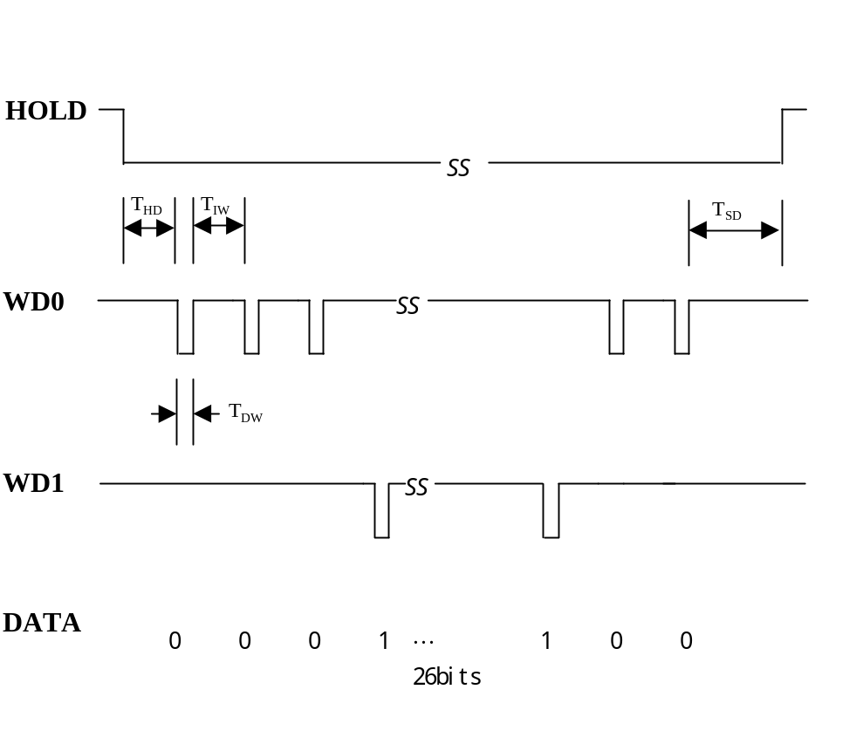
Symbol | Specification | Representative value
T_{HD} | Send data to active time extension | 2ms
T_{SD} | Send data to finish time extension | 2ms
T_{DW} | Data impulse width | 80μs
T_{IW} | Data impulse interval width | 1ms

Reading Type：

Standard design -- card can’t be read again within the range of read antenna after read once. User must move it out of reading antenna range first, swipe card again & can be read.

Special design -- card can be read continuously within the range of read antenna.

TTL Interface RS232 Data output format

  - 9600bps,N,8,1
  - CHECKSUM: card 10byte DATA entire do XOR operation

02 | 10ASCII Data Characters | Checksum | 03

Example: card number: 62E3086CED
Output data:36H、32H、45H、33H、30H、38H、36H、43H、45H、44H

CHECKSUM: (62H) XOR (E3H) XOR (08H) XOR (6CH) XOR (EDH)=08H

2. Time sequence chart

